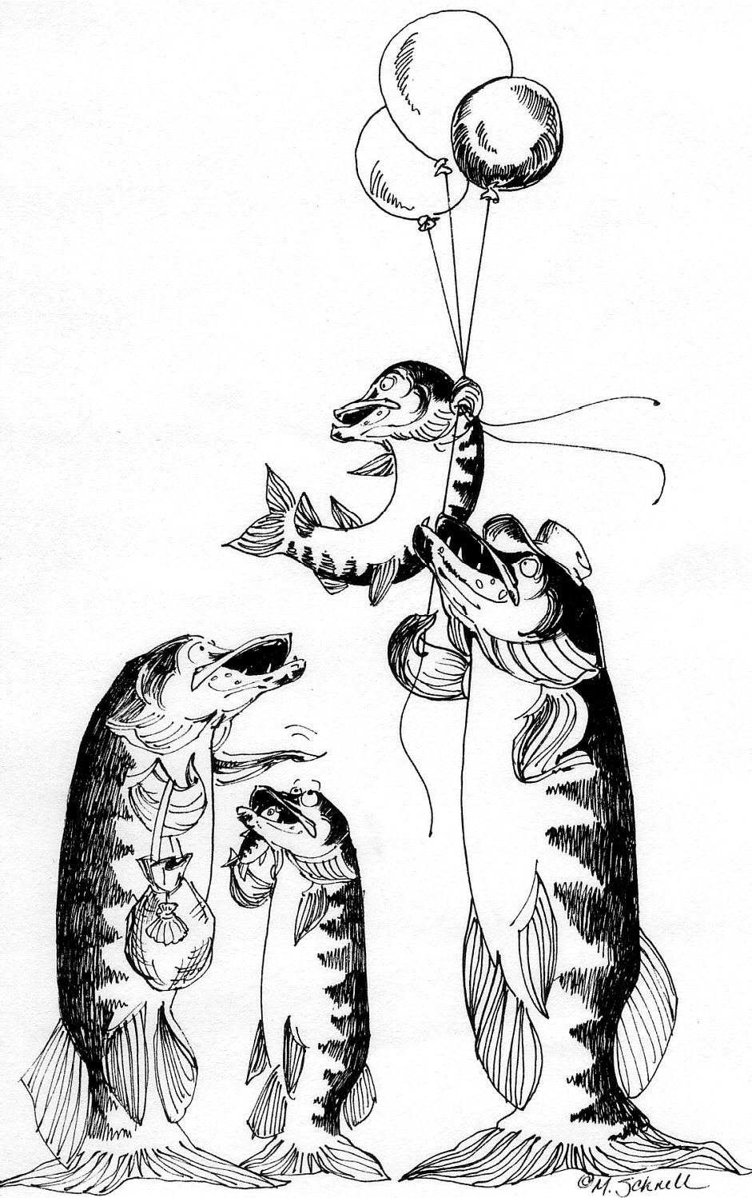
50th Annual
Musky Jamboree Arts & Crafts Fair
August 13, 2006

Downtown Main Street
Boulder Junction, WI 2006 Application

2006 marks the 50th year anniversary of the Musky Jamboree in Boulder Junction, WI. We are planning a full weekend of celebration and activities. The Arts and Crafts Fair has and will be the biggest draw of the weekend. We look forward to hosting a spectacular array of original arts and crafts at this year’s event.

Calendar
March 1, 2006 - applications due with fees
Beginning of April - notifications mailed
August 13, 2006 – 6:00am set-up
August 13, 2006 – Art & Crafts Fair,
8:00 am - 4:00 pm

Applications postmarked after March 1, 2006 will be accepted if a late fee of $15.00 is included. Applications will be returned if late fee is not included.

Fees
Booth Fee:
Spaces are 10’ deep and 10’ wide.
$75.00 per booth

Late Fee:
Applications postmarked after March 1, 2006 will be accepted if a late fee of $15.00 is included. Applications will be returned if late fee is not included.

NO REFUNDS after juried acceptance.

Jury Procedure
This is a juried show requiring submission of five photos, signed application and booth fee. You should submit three showings of your work, one of you at work and one of your booth display. Print your name/company on the back of each photo. Applications without photographs will not be accepted. See fee schedule for cost. The jury will consist of Boulder Junction Chamber members, staff and a local artist with over 30 years experience in shows. NO REFUNDS will be given after acceptance. Booth fee will be returned if not accepted. Photos will be returned the day of the show.



Rules
Eligibility:
Artist/Crafter must be present the day of the show. Work must be of original concept, design and execution; no kits, commercial molds, etc. Photos submitted for jurying must be representative of the majority of the work to be exhibited. Jurors will use booth photos to judge the overall appearance and make-up of your display. An exhibitor found selling store merchandise, manufactured items, purchased crafts, etc.; will be evicted from the show.

Exhibits:
The Arts and Crafts Fair is held outdoors on our wide paved, Main Street. Exhibitors must supply their own canopies, tables, etc. Show is on rain or shine. Electricity is not available to any booth. Past artists and crafters submitting their application by March 1st will be honored the same booth location as last year. We cannot guarantee location after the deadline. A map of your booth location will be sent along with your letter of acceptance.

Display Hours:
8:00am to 4:00pm. All booths may start set-up at 6:00am and must be ready to operate by 8:00am. All booths must be in operation until 4:00pm. Exhibitors removing items prior to 4:00pm will not be invited to exhibit in the future.

Parking:
All vehicles must be moved off Main Street by 8:00am. Please see a Chamber volunteer for questions regarding designated parking areas. There is no parking in the Boulder Junction Marketplace parking lot. This is for customer use only and the service organization permitted to sell food.

Thank you for your interest in our show. Please contact us if you have further questions.

Boulder Junction Chamber of Commerce
PO Box 286
Boulder Junction, WI 54512
715-385-2400, 715-385-2379 fax
boulderjct@boulderjct.org
www.boulderjct.org

50th Annual
Musky Jamboree Arts & Crafts Fair
August 13, 2006

Downtown Main Street
Boulder Junction, WI 2006 Application

Artist’s Name: _______________________________________ Number of Booths Needed: _____

Company Name: _____________________________________ Past Crafter? yes / no

Address: ___________________________________________ License. Plate #: ______________

City: _________________________________ State: _____ ZIP: ___________

Phone: _______________________________ Alternate Phone: _______________________________

E-Mail Address: ______________________________________

WI Sales Tax #: ________________________ Social Security Number: _________________________

Please describe your work and items to be exhibited: __________________________________________

______________________________________________________________________________________

______________________________________________________________________________________

______________________________________________________________________________________

I have read this application, certify that my work is qualified under the guidelines outlined and agree to abide by all rules and conditions. If accepted, I agree to exhibit and present only items approved by the Boulder Junction Chamber Arts and Crafts Fair Committee. I also agree to leave the premises clean and free of debris. The Boulder Junction Chamber of Commerce is not responsible for loss of or damage to, merchandise or personal property from any cause whatsoever. I understand that NO REFUNDS will be given after acceptance and that the booth fee will be returned if not accepted.

Artist Signature: _________________________________________________________

Would you like to receive detailed information regarding the full weekend of celebration and activities for our
50th Musky Jamboree? yes / no

This application must be submitted, with signature, and accompanied by full payment to:

Boulder Junction Chamber of Commerce
PO Box 286
Boulder Junction, WI 54512

Checklist:
- Completed Application
- Five photos
(3 of work, 1 at work, 1 of display)
- Booth Fee $75.00/10x10 space
- Late Fee $15.00 if postmarked after 3/1/2006
- Self Addressed Stamped Envelope

FOR OFFICE USE ONLY

App. Received on ____/____/____ Check # ________ Amount: ________

I hereby accept the above application _________________________________________________________________
Authorized By Date

Booth Number Assigned: __________

